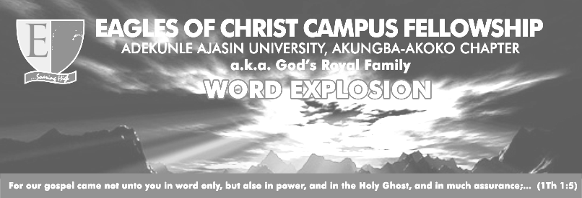
Golden Text: Romans 11vs 19-20
THEME: A PERFECT HEART UNTO THE LORD TEL: 07068708093
TOPIC: ETERNAL SALVATION 07038507050
TEXT: Hebrews 5 vs 7 – 9.
SPEAKER: Bro Akinnubi Aderopo
DATE: 26-06-2018 Email: eccfaaua@yahoo.com

“You will say then, “Branches were broken off so that I could be grafted in”. Granted. But they were broken off because of unbelief, and you stand by faith. Do not be arrogant, but be afraid”. (NIV)
Blessed be the Lord God Almighty who is enthroned in the heavens. (Halleluyah).
Last week, God conveyed to us His counsel on the presentation of the heart via our mouth….that our externalities (what we do in all its totality) is a product or outward manifest expression of our internal reality (who we are).
Brethren , we are living in the days of which the Scriptures expressly speaks in I Timothy 4vs1----- a time in which grace has been defined as a license to sin. In our days, several theories abound concerning eternity, one of which is purgatory among others. Infact, questions and diverse conclusions have ensued as touching “if” and “how” an ever loving God can banish His handwork (in fact, man) to eternal damnation (Matt 25:34, 41).
Although it has been widely attacked, yet, eternal salvation is a truth. Paul did not carelessly stray in his thoughts while raising the issue of eternal salvation in Hebrews 5:9 (I Cor 7vs10, 12, 25). However, eternal salvation as all other great provisions of God is conditional. God in His sovereignty provided it; man will only access it via right response. (Hebs 5:7-9, Phi 2:12-13, John 10:26-28).
- How can a man who had once accepted Christ, live a life of sin (backslidden) and yet claim to be eternally secured? (Gal. 2:18, Exo. 32:33, Ezekiel 18:4,).

- What is the fate of an unrepentant backslider? (II Pet. 2:20-22, Hebs. 10:28-29, 38-39, Eze. 33:12-13, I John 3:15).
Beloved brethren, it is precarious to live estranged or separated from Christ and yet claim to be eternally secured. Beware!!!

You will do well to study these scriptures in preparation for the next word explosion
Wednesday: Review of this outline
Thursday: Acts 1:9-11
Friday: Acts 9:1-4
Saturday: Acts9:5-8
Sunday: Acts 9:9-11
Monday: 2 Pet 3: 8-10
Tuesday: Rev 19: 11-12
QUOTE FOR THE WEEK: “If our faith does not make us pine after holiness, it is not better than the faith of demons” (James 2:18-19)

